Bullock Spirit Week 
Monday Feb. 3rd  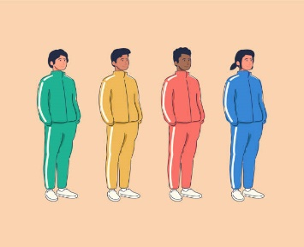 | Tuesday Feb. 4th   | Wednesday Feb. 5th   | Thursday Feb. 6th   | Friday Feb. 7th  
“Positive Attitude is no sweat!”  - Wear your comfy clothes and be sure to spread positivity to others. | “A positive attitude makes our community of Glassboro beautiful!”  - Wear Glassboro attire and/or Glassboro colors. | “A positive attitude will lead to positive outcomes!”  - Wear a positive message shirt, smiley faces, hearts, or any attire that promotes a positive attitude. | “Our positive attitudes are very bright!”  - Wear bright colors, sunglasses, hats, or anything you would wear when you are having fun in the sun. | “Doesn’t matter if you win or lose it’s all about your positive attitude!”  - Wear favorite sports team attire including Logos, color of favorite team, and/or jerseys.

Monday Feb. 3rd | Tuesday Feb. 4th | Wednesday Feb. 5th | Thursday Feb. 6th | Friday Feb. 7th
“Tener una actitud positiva es facil!  - ¡Use ropa comoda y asegurese de transmitir positividad a los demas! | “Una actitud positiva hace que nuestra comunidad de Glassboro sea hermosa!”  - ¡Use vestimenta de Glassboro, o colores de Glassboro! | “Una actitud positiva resulta en conducta positiva.”  - Use una camiseta con mensaje positiva, caritas sonrientes, corazones o cualquier vestimenta que promueva una actitud positiva.” | “Nuestras actitudes positivas son muy brillantes!”  - ¡Use colores brillantes, gafas de sol, sombreros o cualquier cosa que use cuando se divierta bajo el sol!” | “No importa si ganas o pierdes, lo importante es tener una actitud positiva!  - ¡Use la camiseta de su equipo deportivo favorito!

Semana de la Actitud Positiva en Bullock

